LEXINGTON Mirror Image

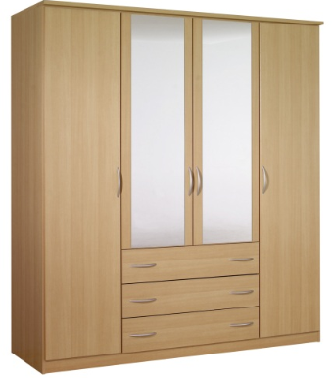

|  |
| --- |
| **DESCRIPTION** |
| LEXINGTON dream designing has introduced an extra wide multi storage cupboard with extra griped surface. The cupboard has a nice feel with smooth surface and the brown color gives it a natural look which enables it to give a relaxing feeling. It will give your house a complete different look and a door with group of chests enable it store as well as hang goods. |

|  |  |  |
| --- | --- | --- |
| **Price** | **2990$** | |
| **Dimensions** | **H** x **W** x **L** | **75in x 22in x 48in** |
| **Features** | **There are four doors. With two bigger and two small with mirrors** | |
| **Finished** | **Polished Fabricated Wood** | |
| **Available in** | **Light Brown and peach** | |